Westslope Cutthroat Trout (WCT) Range-wide Database Update:
Historical Range, Current Status, Risk and Population Health Determinations and Population Restoration Potential Protocols
2008
WCT Conservation Coordination Working Group
Prepared by Bruce May and Shannon Albeke
(Revised Version, including Risk Characterization Tables. 5/13/2009 IDFGc2)

This revision provides information for updating the range-wide status and conservation database for westslope cutthroat trout (WCT; Oncorhynchus clarkii lewisi) This update is based on a modification of the original database protocol applied in 2002. This update will: 1) update estimates of historically occupied habitats; 2) validate current distribution of WCT and identify additional attributes associated with current distributions; 3) identify additional conservation populations and revise information for currently identified populations, including assessing relative population health using a ranking system approach adapted from Rieman et al. (1993) and evaluate risks associated with genetic introgression and catastrophic disease; and 4) evaluate potential for further expansion and restoration of conservation populations within the context of the broad historical range. The protocol detailed below represents a modified version consistent with with versions recently used for Yellowstone cutthroat trout (YCT), greenback cutthroat trout (GBCT), Colorado River cutthroat trout (CRCT), Bonneville cutthroat trout (BCT), Lahontan cutthroat trout (LCT) and Rio Grande cutthroat trout (RGCT). This protocol is specifically tailored to a WCT status update. The assessment is being done as a critical component of range-wide coordination for WCT. Completion of the status update will be helpful in meeting the objectives of the range-wide conservation effort in a number of respects. This status update should be viewed as a 2008 ‘snap shot’ of WCT status, distribution and relative population health. This status update will serve as a valuable benchmark for evaluating future changes that are anticipated to occur.

Note: 1:100,000 and mixed scale Hydrography from the participating state agencies was used during this process, not the NHD.
This status update will use National Hydrography Dataset (NHD) as the base geographic information system (GIS) hydrography layer for the effort (see http://nhd.usgs.gov/ for more information on NHD). The NHD layer has become the most nationally accepted GIS layer for displaying stream and lake hydrography. In addition, all of the stream and river mapping has been done at the 1:24,000 scale for NHD. The USFS Natural Resource Information System (NRIS) has ArcGIS tools available that greatly assist with this process. An event creation tool, developed by the NRIS team, will be used to geo-reference WCT population segments. This tool utilizes a “point–and-click” user interface to reference these population segments against the NHD stream network.
To maintain continuity and consistency, only those streams and lakes identified on the NHD stream and lake layers will have information entered into the database. Applying this criterion will mean that some intermittent and ephemeral streams that could potentially provide habitats used or occupied by WCT, especially during high flow periods, will be omitted. Some lake environments may be omitted also. It is anticipated that these streams and lakes will be added during subsequent efforts to update the NHD layers. This version of the database has been expanded to include information for lakes and reservoirs identified on the NHD lake layer.
Information sources will be identified and linked to rated levels of reliability to better judge information quality (Table 1). Information associated with judgment calls and anecdotal sources, in general, may be viewed as being less reliable and/or accurate than information developed as part of detailed surveys and studies that have undergone substantial analysis and review.
All data will be entered in “real-time” at workshops with groups composed of biological experts that will evaluate all waters within 4th level hydrologic units (HUC’s) and GIS and/or database experts charged with entering and editing those evaluations until the entire group has reached consensus within a particular HUC. There are approximately 62 4th level HUC’s within the historic range of WCT. During the completion of the assessment for each HUC, the teams will be asked to employ a systematic approach to ensure that all information is included in the database. The use of 4th level HUC’s will be for accounting purposes only. All data will be geo-referenced as either points (e.g. barrier locations), WCT mapping segments (e.g. stream and lake habitat segments occupied by WCT), groupings of occupied segments into discrete conservation populations using a team approach, and opportunities for population restoration or expansion.
Table 1. Example look-up table for data sources with a relative index values for information reliability and accuracy.
Information ‘Source | Relative Degree of Reliability
Anecdotal Information | Low 1
Letter | Low 1
Professional Judgment | Moderate 2
Cursory Reconnaissance | Moderate 2
Information derived from minor sampling; Contained in agency databases, reports and summaries (generally, non-peer reviewed) | High 3
Information derived from major sampling; Generally contained in agency databases, a Thesis or Dissertation or a published paper (peer reviewed). | Highest 4
This protocol is partitioned into four primary components. First, the team will verify streams and lakesconsidered to have been historically occupied by WCT at the time of the first European exploration of the Northern Rocky Mountains (circa 1800). Secondly, information associated with current distributions of WCT including density, genetic status, presence of non-native species and habitat information will be entered into the database and displayed as mapping segments. Thirdly, conservation populations will be identified (either as an individual stream or a network of streams and lakes occupied by WCT, and the relative health and the risks to persistence for each population will be evaluated. Relative health and risks will be assessed based on three aspects: 1) genetic introgression, 2) disease, and 3) population size and demographics. Health and risk determinations represent relative evaluations indicating higher or lower levels of concern. All designated conservation populations, including those associated with lakes that are maintained by natural reproduction, will have population health and risk assessments completed. Locations of lakes that support WCT will be shown on the maps. WCT populations supported entirely by annual or routine stocking will not be included as part of this assessment (they are, however, viewed as valuable recreation populations). The exception would be those populations serving as wild broods that require periodic stocking to bring in new genetic material as part of the brood maintenance plan. The fourth component of the database will provide information on the potential for creation or expansion of conservation populations within the historical range boundary. The outer boundary of the historical range will be considered in this assessment and some waters within this outer boundary might not have been historically occupied due to dispersal barriers).

All data entry will be date-stamped for each record in each table to ensure that date of assessment evaluation is recorded with each line of information. Each database update will be archived in its entirety and coded by the year it was done. The date stamp will then be used to monitor changes over time and to find the most current information.

Definition for terms used for this protocol
Population mapping unit (segment) – each WCT occupied stream, or segment of stream, will be treated as a separate mapping unit or segment. Specific information relative to stocking records, presence of non-native fish, WCT density, habitat quality and relative stream segment width, lake depth measurements, etc. will be recorded for each segment. Connectivity between these segments will be the basis for identification of conservation populations.

Conservation Populations – A conservation population represenst a combination of mapping segments that when united together represent a conservation unit. The identification of conservation populations is primarily the responsibly of the fishery agencies having jurisdictional authority. Conservation populations can exist in a genetically unaltered condition (e.g. core conservation populations with genetic analysis indicating greater than 99% purity and/or there is reason to believe that the genetics are unaltered); and/or they can be based on unique ecological, genetic and behavioral attribute of significance even with some level of genetic introgression (See Cutthroat Trout Management: A Position Paper – Genetic Considerations Associated with Cutthroat Trout Management). Conservation populations may exist as a network of subpopulations or streams; or they may exist as an independent stream or stream segment.
Core Conservation Population – Those conservation populations that are known to
be genetically unaltered by hybridization or with an extremely high probability that the population is unaltered by hybridization. WCT from these habitat segments for these conservation populations have been tested and found to be unaltered or habitat segments that are suspected to be unaltered based on no record of stocking with potentially hybridizing species and no potentially hybridizing species being present.
Networked-population – infers that interbreeding between subpopulations (population mapping segments) can occur within a few generations (3-15 years). Also referred to as a connected or meta-population. These populations occupy two or more streams that are connected or networked together. All subpopulations within a networked population must have at least the potential for genetic exchange among all other subpopulations within the networked population.
Sub-Population – A discrete component of a meta-population, connected or networked population.
Non-Networked Population (Isolated or Independent Population) – Specific populations that occur in a single stream or lake). Included would be lakes that have only minor stream segments directly connected to the lake in certain situations these streams may not be identified on the stream layer.
Genetic Risk – risk of initial or on-going genetic introgression (hybridization) with introduced species or subspecies. It should be noted that in specific portions of the WCT range, principally the Columbia River Drainage, native redband or rainbow trout (anadromous or resident) co-evolved with WCT. Recent information (Kozfkay et.al. 2007) suggests that a low level (generally less than 10%) of “natural” genetic introgression may occur in some populations
Relative Population Health – evaluation of relative health based on several characteristics associated with the population. These characterizations can be linked to the influences of deterministic or stochastic factors that could lead to reduced viability for a population. The relative health determination is linked to temporal attributes, population size, production considerations and degree of connectedness within the population. The relative health evaluation does not provide a definitive assessment of population health, but rather the relative population health evaluation provides a generalized view of a populations health much like a human health physical exam provides a generalized view of an individuals health.
Significant Disease (Pathogens) Risk – Based on those diseases and the associated pathogens that have the potential to cause significant population decline. Including, but not limited to the following: whirling disease, furunculosis, infectious pancreatic necrosis virus, etc.
Competing Species – Those species that compete with cutthroat trout for food and space. These species can be salmonid or non-salmonid. Generally, these would be non-native species that have been introduced within cutthroat trout habitats. Certain competing species (i.e., brown and brook trout) are predatory on cutthroat trout. Introduced rainbow trout can be viewed as both a competing and hybridizing species. For WCT, native redband or rainbow trout would not be considered a competing species.
Hybridizing Species – Those species or subspecies of trout that readily hybridize with cutthroat trout, primarily introduced rainbow trout. Hybridizing fish can also include subspecies of cutthroat trout that have been introduced into habitats outside of their respective historic ranges. For WCT, native redband and rainbow trout have been shown to hybridize with WCT.
Genetic, density and habitat information will be developed for each mapping segment. Genetic and disease risks along with a relative population health determination will be completed for each conservation population.

Barriers
All new barriers and new information on existing barriers of significance to WCT conservation will be added to the database. Since barriers to fish movement (either long-term historical, natural short-term or anthropogenic barriers) are significant components of conservation, each known significant passage barriers will be identified as a map point. Specific information associated with each barrier will be used to assess whether individual habitat segments were likely historically occupied by WCT, to assess potential influences of genetic introgression or to assess the influence of disease to existing WCT populations. Presence of barriers will also be important in determining whether subpopulation have the capability of interacting with other subpopulations. Identification of barrier locations and distinguishing barrier characteristics are very important in conservation planning.
To determine the historical distribution, those barriers that represent long-term geologic features that would serve to influence historical distributions will be identified, where known. These are barriers that would have precluded WCT occupation on or before 1800 (i.e. the segments were historically barren of WCT). These barriers will be located (as points in ArcGIS) on the stream and river hydrography layers. During mapping of current WCT distributions, other significant barriers (e.g., natural short-term and/or anthropogenic barriers) will be identified and located (as points in ArcGIS) and their associated characteristics, including barrier type (Table 2), blockage extent (Table 3), and significance (Table 4), will be determined and entered into data tables that are linked to the GIS points. Only barriers believed to have a significant influence on cutthroat distribution or population integrity will be identified. An attempt will be made to include all total barriers; however, surveys of all waters within the historical range of WCT to identify fish barriers have not been completed, so only known barriers will be identified. The source of information used to locate each barrier and document its associated characteristics will be entered into a separate data table (Table 5). If a particular barrier extends over an extended distance (e.g. temperature or chemical barrier) the downstream point will be located on the GIS. Barrier identification will be the first action taken of the four parts of the database update. Starting with the lower-most portion of the 4th code HUC, barriers will be located from the downstream-most to the upstream-most reaches in a systematic fashion until the mainstem and all tributaries and sub-tributaries are covered, and all known barriers of significance have been identified. Barrier significance is linked either to how a barrier is influencing current distribution, or how a barrier could be important to future conservation.
Table 2. Types of barriers to upstream fish movement (Check the one that best applies to each barrier).
Code | Barrier Type
1 | Water diversion
2 | Fish culture facility/research facility
3 | Temperature
4 | Bedrock
5 | Culvert
6 | Debris
7 | Insufficient flow
8 | Manmade Dam
9 | Manmade temporary restoration barrier
10 | Pollution
11 | Beaver dams
12 | Velocity barrier
13 | Waterfall
14 | Unknown

Table 3. Extent of blockage caused by barriers (Check the one that best applies).
Code | Blockage Extent
15 | Complete
16 | Partial
17 | Unknown

Table 4. Barrier significance (Check all that apply for each barrier).
Code | Barrier Significance
1 | Historically significant – Limited historical distribution
2 | Prevents or limits introgression
3 | Prevents ingress of competing species
4 | Temporary, but presently prevents introgression or ingress of competing species
5 | Confines population to small area of usable habitat
6 | Limits or precludes opportunity for population re-founding
7 | Limits expression of life history characteristics
8 | Unknown

Table 5. Information sources associated with the barrier (Check one that best applies).

Code | Barrier Information Source
18 | Low level of reliability-- Anecdotal Information
19 | Moderate level of reliability – Professional Judgment - Ocular Reconnaissance
20 | High level of reliability -- Minor Sampling – minor sampling; contained in agency databases, reports and summaries (generally, non-peer reviewed)
21 | Highest level of reliability -- Major Sampling – Major amount of sampling; Generally contained in agency databases, a Thesis or Dissertation or a published paper (generally, peer reviewed).

Part 1 – Historical Distribution
The historical distribution of WCT, including lakes, will be verified and any changes to past information or addition of new information will be recorded. The historically occupied range of WCT will be assessed based on their believed distribution at the time Europeans first entered the Rocky Mountain West (approximately 1800). The NHD hydrography layers (1:24,000 scale) will be used to maintain consistency of information. Fishery professionals familiar with each major drainage basin (4th code HUC) will define historic distribution by adjusting the NHD stream layer within each HUC. The historical range will be based primarily on historical fisheries data, fisheries reports, and published historical accounts, augmented with personal knowledge of the areas, known anecdotal information, known habitat restrictions, and known barriers of historical significance. Changes to the historical range identified during the 2002 assessment that result in major changes (i.e. adding or deleting 5th level HUC’s will have to be justified and rationales for those changes need to be documented as recorded comments. Barriers of historical significance are those that would have precluded WCT from occupying habitat segments at any time prior to 1800. These barrier determinations, by necessity, will be based primarily on professional judgment (Table 6).
Table 6. This table provides possible rationales for exclusion or inclusion of habitat segments as historical WCT habitat.

Include or exclude |  | Reason
Exclude |  | Habitat limited – Primarily based on judgment regarding gradient, elevation, temperature
Exclude |  | Geologic barrier – May be based on judgment. Must correspond to a mapped barrier location and must be a complete barrier to fish movement.
Include |  | Anecdotal information (e.g., newspaper, letter, journal, etc.)
Include |  | Historical scientific survey data (e.g., published report)
Include |  | Judgment

Part 2 -- Current Distribution--Genetic Status, Densities and Habitat Conditions
This part of the analysis will identify all habitat segments currently occupied by WCT. This is not an identification of conservation populations that will come in Part 3. Before identifying those habitat segments currently occupied by WCT, the process of identifying all other barriers of significance to current distribution of WCT must be completed. These additional barriers should include any barrier that does, or could, significantly influence WCT distribution, life history expression, spawning, competition and hybridization. After locating these barriers, the lower and upper bounds of all stream segments and lakes presently occupied by self-sustaining WCT will be located. For each habitat segment that currently supports self-sustaining WCT, the data and data source used to justify inclusion will be identified (Tables 7 to 20). Two potential types of self-sustaining WCT could be present: 1) aboriginal or 2) restored (reintroduced) (Table 7). Only self-sustaining populations (i.e., no routine augmentation with hatchery fish unless linked to a wild brood program) of WCT will be addressed in this status review. All potentially occupied habitats must be reviewed, so workgroups will work in a systematic fashion generally from the downstream end of each HUC to the headwaters. The specific information associated with current occupancy will be tracked by habitat segment (Tables 7 to 20). When delineating habitat segments currently occupied by WCT, barrier locations must be considered and included in the rationale for delineating each segment (in addition, barrier significance attributes may be adjusted as the workgroup determines how each barrier might be affecting WCT within each stream segment). Information associated with each habitat segment occupied by WCT must be recorded as each segment is identified (Tables 7 to 20). Remember, each identified habitat segment currently occupied by WCT must have all attributes in common. If one or more attributes change, a new segment is created. There will be identifiers associated with each table to denote whether the information in the respective tables is associated with lake or stream habitat segments. Table 8 identifies fish stocking associated with the occupied habitat segments. Genetic information and status will be identified for each WCT mapping segment (Tables 9 and 10). For Table 9, base the category determination on genetic information from the largest sample and/or the most recent sample. Table 10 contains specific genetic information collected for individual sampling and analysis efforts. Information in Table 10 can be used to generate the genetic characterizations captured in Table 9. Relative density information will be used to approximate effective population size for conservation populations identified in Part 3 of the protocol. Relative density or density estimates for a stream mapping segments will be recorded as the number of sexually mature YCT adults (e.g. 15 cm and longer for small streams and 30 cm and longer for large streams and rivers). If a stream mapping segment supports both non-migratory and migratory YCT (including those YCT that occupy lakes but use streams for spawning) base the density estimate on fish 30cm and larger. When actual density estimates are reported they must be linked to the estimator that was used to make the estimate (Tables 11-13).
Habitat information will be identified for each WCT stream mapping unit (Tables 14-18). Specific habitat information will not be included for lake segments. The presence of non-native fish will be recorded for each stream segment and lake occupied by WCT (Tables 19 and 20). - Total stream length and lake surface acres currently occupied will be developed through GIS capabilities.

Table 7. Origin of self-sustaining WCT (Check one that best applies).
Code | Origin
15 | Aboriginal – naturally occurring population
16 | Restored – human restoration to start population
17 | Unknown

Table 8. Fish stocking associated with the occupied habitat segment (Check all that apply).
Code | Fish Stocking Status
1 | No Record of fish stocking
2 | Record of rainbow stocking (coastal source)
3 | Record of brown trout stocking
4 | Record of brook trout stocking
5 | Record of lake trout stocking
8 | Record of WCT stocking
 | Record of redband/rainbow stocking
9 | Record of other cutthroat trout subspecies being stocked. Specify:
10 | Other non-native fish stocked. Specify:

Table 9. Genetic status of WCT within a stream segment or lake (Check one that best applies)
Code | Genetic Status
1 | Genetically unaltered (<1% introgression detected) as a result of introduced species interaction– tested via electrophoresis or DNA
2 | >1% and <10% introgressed (hybridized) with introduced species – tested via allozyme or DNA and introgression indicated to be from a hybrid swarm. This range of introgression may include WCT that interact with native redband trout (anadromous or resident) that do not exist as a hybrid swarm (personal communication with Don Campton, FWS)
3 | >10% and <25% introgressed (hybridized) with introduced species – tested via allozyme or DNA and introgression indicated to be from a hybrid swarm
4 | >25% introgressed (hybridized) with introduced species – tested via allozyme or DNA and introgression indicated to be from a hybrid swarm
5 | Not genetically tested -- Suspected unaltered with no record of stocking or contaminating species present
6 | Not genetically tested -- Potentially hybridized with records of introduced hybridizing species being stocked or occurring in stream
7 | Hybridized and Pure populations co-exist (sympatric mixed-stock) in stream (use only if there is evidence of reproductive isolation, non-random mating, and/or genetic testing has been completed)

Table 10. Specify the specific information associated with genetic sampling and analysis. More than one entry can be made for a stream segment or lake. (Add the specific genetic information in this table)(This Table structure may be different than represented. Final structure will be added later.

Sample Number | Collection Date | Collection ID | Number of Fish Sampled | Analysis Date | Analysis Code | % Non-WCT Genes

Analysis Code | Genetic Analysis
1 | Allozymes
2 | PINES
3 | Microsatellites
4 | DNA

Table 11. Population density (numbers per mile) of sexually mature adults (15 cm small streams with non-migratory fish and 30 cm for larger streams and rivers with non-migratory and migratory fish; also equates to age 2+ and age 3+ fish) within stream mapping segment. Include the spawning density of migratory fish that use the segment for reproduction (Check the one that best applies). If a specific density estimate is available, specify the density within the appropriate density range.

Code | Mapping Segment Adult Fish Density
1 | 0 to 50 fish per mile (Specific density within this range, if available__________)
2 | 50 to 150 fish per mile (Specific density within this range, if available__________)
3 | 151 to 400 fish per mile (Specific density within this range, if available__________)
4 | 401 to 1000 fish per mile (Specific density within this range, if available__________)
6 | 1001 to 2000 fish per mile (Specific density within this range, if available _______)
7 | Over 2000 fish per mile (Specific density, if available _________________)
8 | Unknown

Table 12. Population estimates of reproductively mature WCT (≥15 cm or ≥30 cm) expressed as number per mile (Complete with specific sample information that applies). Use this information to provide the specific density value for Table 11.
Sample ID | Sample Date | Estimated fish/mile | Coefficient of Variation % | 95% Confidence Interval | Estimate Type Code

Code | Population Estimate Type
1 | 3 pass removal
2 | 2 pass removal
3 | Relative abundance expansion
4 | Mark-recapture
5 | Census from spawning trap
6 | Snorkel survey

Table 13. Information sources associated with the fish density information (Check one that best applies).

Code | Fish density Information Source
18 | Low level of reliability-- Anecdotal Information
19 | Moderate level of reliability – Professional Judgment - Ocular Reconnaissance
20 | High level of reliability - Minor Sampling – minor sampling; contained in agency databases, reports and summaries (generally, non-peer reviewed)
21 | Highest level of reliability -- Major Sampling – Major amount of sampling; Generally contained in agency databases, a Thesis or Dissertation or a published paper (peer reviewed).

Table 14. Relative quality of occupied stream habitat (Check one that best applies). Refer to attachment B for optimal desired habitat reference conditions.
Code | Habitat Quality Determination
18 | Excellent habitat quality (e.g., majority of attributes in optimal condition (e.g. ample pool environment, low sediment levels, optimal temperatures, quality riparian habitat, ample stream flows,etc.)
19 | Good habitat quality (may have some habitat attributes that are slightly less than ideal)
20 | Fair habitat quality (has a greater number of attributes that are less than ideal)
21 | Poor habitat quality (most habitat attributes reflect inferior conditions
22 | Unknown

Table 15. For stream segment habitat quality determinations rated as good to excellent, identify the three most important habitat characteristics that influenced the quality determination (Check up to three that best apply). Refer to attachment B for optimal desired habitat reference conditions.
Code | Quality Characteristics of Primary Importance for Good to Excellent Habitat
1 | Substrate fine sediment (less than 6.3 mm) levels generally within 0 to 24%.
2 | Water temperatures within 8 to 16 C during spawning and incubation periods.
3 | Pool habitat within 35 to 60% of total stream habitat area.
4 | Amount of stream habitat in excess of 6 miles.
5 | Stream shading within 50 to 70% during mid-day.
6 | Stream bank vegetative cover greater than 25%
7 | Stream bank stability greater than 90%
8 | Other Attributes. Please Specify:

Table 16. For stream segment habitat quality determinations rated as fair to poor, identify the three most important habitat characteristics that influenced the quality determination (Check up to three that best apply). Refer to attachment B for optimal desired habitat reference conditions.
Code | Quality Characteristics of Primary Importance for Fair to Poor Habitat
8 | Substrate fine sediments (less than 6.3mm) exceed 25%.
9 | Water temperatures in summer consistently above 16 C or below 8C.
10 | Amount of pool habitat either below 35% or above 60%
11 | Amount of stream habitat less than 17 miles.
12 | Mid-day stream shading either less than 50% or greater than 70%.
13 | Stream bank vegetative cover less than 25%.
14 | Stream bank stability less than 75%.
15 | Other Attributes. Please specify:

Table 17. Approximate width of occupied stream segment (Check one that best applies).
Code | Average width of occupied stream segment
23 | < 5 feet
24 | 5 to 10 feet
25 | 10 to 15 feet
26 | 15 to 20 feet
27 | 20 to 25 feet
28 | > 25 feet
55 | Unknown

Table 18. Information sources associated with the stream habitat information (Check one that best applies).

Code | Habitat Information Source
18 | Low level of reliability-- Anecdotal Information
19 | Moderate level of reliability – Professional Judgment - Ocular Reconnaissance
20 | High level of reliability - Minor Sampling – minor sampling; contained in agency databases, reports and summaries (generally, non-peer reviewed)
21 | Highest level of reliability -- Major Sampling – Major amount of sampling; Generally contained in agency databases, a Thesis or Dissertation or a published paper (peer reviewed).

Table 19. Presence of non native fish and native redband/rainbow trout sympatric with WCT in the mapping segment stream or lake (Check all that apply).
Code | Presence of Non-Native Fish
1 | No non-native fish present
2 | Rainbow trout
3 | Brown trout
4 | Brook trout
5 | Lake trout
6 | Native Redband/rainbow trout
7 | Large-spotted YCT
8 | Other cutthroat trout subspecies. Specify:
9 | Other trout. Specify:
10 | Other fish. Specify:
11 | Unknown

Table 20. Information sources associated with the presence of non native fish and native redband/rainbow sympatric with WCT (Check one that best applies).

Code | Non-native and/or native redband/rainbow trout Information Source
18 | Low level of reliability-- Anecdotal Information
19 | Moderate level of reliability – Professional Judgment - Ocular Reconnaissance
20 | High level of reliability - Minor Sampling – minor sampling; contained in agency databases, reports and summaries (generally, non-peer reviewed)
21 | Highest level of reliability -- Major Sampling – Major amount of sampling; Generally contained in agency databases, a Thesis or Dissertation or a published paper (peer reviewed).

Part 3 -- Change in Focus – Identification of Individual Conservation Populations and Application of Relative Health and Risk Evaluations for each Population
At this point, the assessment will change from a focus on WCT occupied mapping segments to a level of assessment related to specific conservation populations and factors that have potential to influence the well-being of these populations. A determination will be made relative to which occupied mapping units (i.e. lake and streams) will be combined into specific conservation populations each having conservation as the primary management focus. Please refer to the definition of conservation populations. Remember: genetics is only one of many factors that can be used to identify a conservation population.
A connected or population network cannot have a total barrier within the population’s habitat network. Both networked populations and independent populations can serve as conservation populations. Identify the nature of subpopulation networks or connectedness of the population (Table 21). Conservation populations can be genetically unaltered (i.e., core conservation populations), or they can reflect a focus on unique traits and characteristics in the presence of documented or potential hybridization (i.e., conservation populations) (Table 22). Identify the life history attributes of the population (Table 23). Information on conservation activities and human-uses (e.g. land uses) will be identified for each conservation population (Tables 24 and 25). It is also important to note that no degree of significance is attributed to the conservation activities or the human uses that are identified as being associated with each conservation population. The significance of the conservation activities and/or human uses to each specific conservation population will have to be addressed in subsequent specific assessments.
Table 21. Degree of network or connectedness with multiple habitats associated with the conservation population (Check one that best applies).
Code | Degree of Habitat Network Associated with Population
1 | Strongly networked. Migratory forms (fluvial/ad-fluvial) must be present and migration corridors must be open (significant connectivity). Occupied habitat consists of numerous (> 5) individual streams w/ sub-populations.
2 | Moderately networked. Migratory forms are present but connection periodically disrupted. Genetic exchange limited at times. Occupied habitat consists of a few (4-5) individual streams w/ sub-populations.
3 | Weakly networked. Questionable whether migratory forms exist within connected habitat; however possible infrequent straying of adults within occupied connected habitat. Occupied habitats consists of 2 to 3 streams w/ sub-populations.
4 | Population not networked or connected. Population functions as an independent entity (single stream or stream segment with no interaction with other sub-populations.

Code | Network Information Source
1 | Low level of reliability-- Anecdotal Information
2 | Moderate level of reliability – Professional Judgment - Ocular Reconnaissance
3 | High level of reliability - Minor Sampling – minor sampling; contained in agency databases, reports and summaries (generally, non-peer reviewed)
4 | Highest level of reliability -- Major Sampling – Major amount of sampling; Generally contained in agency databases, a Thesis or Dissertation or a published paper (peer reviewed).

Table 22. Conservation Population Qualifier (Check one that best applies)

Code | Conservation Population Qualifier
5 | Core Conservation Population (must be tested genetically unaltered – greater than 99% WCT genes and/or only have stream and lakes segments suspected of being unaltered based on no stocking records of hybridizing fish and/or no hybridizing fish present…Tables 9 and 10).
6 | Conservation Population with Known or Probable Unique Life History (fluvial, ad-fluvial, or non-migratory) Or may include populations that represent the last, best WCT populations within a given watershed or drainage basin.
7 | Conservation Population with Known or Probable Ecological Adaptation to extreme environmental condition (e.g. temperature, alkalinity, pH, sediment)
8 | Conservation Population with Known or Probable Predisposition for large size or unique coloration
9 | Conservation Population of Mixed Genetic Makeup – An aggregate of sub-populations or habitat segments that include both non-introgressed and introgressed individuals identified as a single conservation unit.

Code | Conservation Population Qualifier Information Source
1 | Low level of reliability-- Anecdotal Information
2 | Moderate level of reliability – Professional Judgment - Ocular Reconnaissance
3 | High level of reliability - Minor Sampling – minor sampling; contained in agency databases, reports and summaries (generally, non-peer reviewed)
4 | Highest level of reliability -- Major Sampling – Major amount of sampling; Generally contained in agency databases, a Thesis or Dissertation or a published paper (peer reviewed).

Table 23. Specific life history attributes associated with the conservation population (Check all that apply).

Code | Life History Attributes
1 | Fluvial disperses locally in one stream or a group of small streams as the home range)
2 | Individuals moving from larger river into tributaries to spawn.
3 | Lacustrine (lake) fish moving into lake tributaries to spawn)
4 | Lake fish moving into outlet stream to spawn)
5 | Unknown

Code | Life History Information Source
1 | Low level of reliability-- Anecdotal Information
2 | Moderate level of reliability – Professional Judgment - Ocular Reconnaissance
3 | High level of reliability - Minor Sampling – minor sampling; contained in agency databases, reports and summaries (generally, non-peer reviewed)
4 | Highest level of reliability -- Major Sampling – Major amount of sampling; Generally contained in agency databases, a Thesis or Dissertation or a published paper (peer reviewed).

Table 24. Conservation activities associated with the conservation population (Check all that apply).
Code | Conservation Actions
1 | Water lease/In-stream flow enhancement
2 | Channel restoration
3 | Bank stabilization
4 | Riparian restoration
5 | Diversion modification
6 | Barrier removal
7 | Barrier construction
8 | Culvert replacement
9 | Installation of fish screens to prevent loss
10 | Fish ladders to provide access
11 | Spawning habitat enhancement
12 | Woody debris placement
13 | Pool development
14 | Increase irrigation efficiency
15 | Grade control
16 | In-stream cover habitat
17 | Re-founded population
18 | Riparian fencing
19 | Physical removal of competing/hybridizing species
20 | Chemical removal of competing/hybridizing species
21 | Public outreach efforts at site (Interpretative site)
22 | Population Expansion (e.g. expanding the occupied area of a specific population)
23 | Population supplementation (e.g. to implement genetic swamping or to reduce potential of bottle necking, etc.)
24 | Special Angling Regulations
25 | Land-use mitigation direction and requirements (e.g., Forest Plan direction, regulation, permit req., coordination stipulations, etc.)
26 | Population covered by special protective mgt emphasis (e.g., Nat’l Park, wilderness, special mgt area, conservation easement, etc.
27 | Other:
28 | None:

Table 25. Human-use associated with conservation population. (Check all that apply).
Code | Activity
1 | Timber Harvest
2 | Range (Livestock grazing)
3 | Mining
4 | Recreation (non-angling)
5 | Angling
6 | Roads
7 | De-watering
8 | Fish Stocking (e.g., non-native fish)
9 | Hydroelectric, water storage and/or flood control
10 | Other
11 | None
12 | Unknown

Conservation Population Risks and Relative Health Evaluations
Only conservation populations will be evaluated for risks associated with genetic and disease influences and each population will be given a relative population health evaluation. It is important to note that these evaluations are not intended to define the inherent probability of persistence or exclusion, but rather to identify index conditions that put a population at greater or lesser risk based on certain attributes.

Genetic Stability Assessment
A genetic stability ranking will be made for each conservation population (e.g., Network- or non-networked) using an index ranking of 1 to 4 to indicate lower to progressively higher levels of possible risk (Table 26). The index should not be viewed as an absolute but rather as an indicator of possible or potential genetic influences
Table 26. Genetic index ranking (Check one that best applies).
Rank | Genetic stability or Risk Characterization
1 | Introduced potentially hybridizing fish cannot interact with existing WCT population. Barrier provides complete blockage to upstream fish movement or potentially hybridizing fish are not present in same or adjacent drainages.
2 | Introduced potentially hybridizing fish are in same stream and/or drainage further than 10 km from WCT population, but not in same stream segment as WCT, or within 10 km where existing barriers exist, but may be at risk of failure.
3 | Introduced potentially hybridizing fish are in same stream and/or drainage within 10 km of WCT population and no barriers exist between introduced species and WCT population. However, introduced hybridizing species have not yet been found in same stream segment as WCT population.
4 | Introduced potentially hybridizing fish are sympatric with WCT in same stream segment.

Code | Genetic Risk Information Source
1 | Low level of reliability-- Anecdotal Information
2 | Moderate level of reliability – Professional Judgment - Ocular Reconnaissance
3 | High level of reliability - Minor Sampling – minor sampling; contained in agency databases, reports and summaries (generally, non-peer reviewed)
4 | Highest level of reliability -- Major Sampling – Major amount of sampling; Generally contained in agency databases, a Thesis or Dissertation or a published paper (peer reviewed).
Significant Disease Influence Assessment
A significant disease influence ranking will be made for each (networked or non-networked population) using a ranking index of 1 to 5 to indicate low to progressively higher levels of risk associated with the possible or potential influence of significant diseases (Table 27). Population isolation and security are important considerations, but cannot be viewed as absolutes. The diseases of concern are those that cause severe and significant impacts to population health and include, but are not limited to, whirling disease, furunculosis, infectious pancreatic necrosis virus, etc. The assessment should be completed and/or reviewed by fish health professional. The level of influence should not be viewed as an absolute but rather as an indicator of possible or potential disease influences.
Table 27. Significant diseases risk influence index (Check one that best applies).
Rank | Risk of Disease Characterization
1 | Significant diseases and the pathogens that cause these diseases have very limited opportunity to interact with existing WCT population. Significant disease and pathogens are not known to exist in the stream or watershed associated with WCT population. Barrier provides complete blockage to upstream fish movement. Stocking of fish from other sources does not occur.
2 | Significant diseases and/or pathogens have been introduced and/or identified in same stream and/or drainage further than 10 km from WCT population, but not in same stream segment as WCT, or within 10 km where existing barriers exist, but may be at risk of failure. Stocking of fish from others source areas requires fish health screening and pathogen free clearance.
3 | Significant diseases and/or pathogens have been introduced and/or have been identified in same stream and/or drainage within 10 km of WCT population and no barriers exist between disease and/or pathogens and diseased fish species and the WCT population. However, diseases and/or pathogens have not yet been found in same stream segment as WCT population.
4 | Significant disease and/or pathogens and disease carrying species are sympatric with WCT in same stream segment but WCT have not tested positive.
5 | WCT population is known to be positive for significant disease and/or pathogens are present. WCT population has a history of impacts from significant diseases. Environmental and/or biological conditions may have intensified disease impact.

Code | Disease Risk Information Source
1 | Low level of reliability-- Anecdotal Information
2 | Moderate level of reliability – Professional Judgment - Ocular Reconnaissance
3 | High level of reliability - Minor Sampling – minor sampling; contained in agency databases, reports and summaries (generally, non-peer reviewed)
4 | Highest level of reliability -- Major Sampling – Major amount of sampling; Generally contained in agency databases, a Thesis or Dissertation or a published paper (peer reviewed).
Conservation Population Relative Health Evaluation
A relative population health evaluation will be completed for each conservation population (i.e. networked or non-networked populations) using an index ranking that includes consideration of four factors (temporal variability, population size, production potential based on habitat quality, and the nature of habitat networks, also see attachment A). General population health will be indexed from low to high by using a 1 to 4 ranking system based on four factors viewed as being important to a population of fish (Table 28). This population health evaluation represents a simplified effort to judge a populations relative health. Several factors have been identified as being of importance to the wellbeing of fish populations. We’ve chosen to utilize only the four factors specified to provide a relative health condition for each population. Our approach was adapted from Rieman et al. (1993). The ranking for temporal variability will be derived as a cumulative total length of stream segments identified as being part of the conservation population. Population size of WCT that are sexually mature (see length criteria described in the fish density portion of the current distribution section) will be derived from the density information associated with the stream segments that make up each conservation population. This portion of each population is a subset of the total population size. Population production potential will be ranked using stream segment information associated with habitat quality, presence of non-native fish, and potential for disease (see attachment A). The nature of habitat networks associated with each population will be taken from Table 21. These four main factors will be weighted to derive a final index as follows: Temporal Variability = 0.7; Population Size = 1.2; Population Productivity (Growth/Survival) = 1.6; and Habitat Network = 0.5. These weighting factors were provided by Dr. Danny Lee and were derived from his work with the BayVAM model that was being applied to fish population analysis at the USDA Rocky Mountain Research Station in Boise, Idaho in the mid-1990’s (D. Lee, initial personal communication in 1998; follow up communication in 2008). The index value for relative population health should not be viewed as an absolute but rather as a relative indicator of possible or potential health.
Table 28. Ranks of various types of general health indicators associated with conservation populations. Individual variable rankings to be generated from the information associated with currently occupied habitat data and specific conservation population information.

Variable | Description | Rank | Criteria
Temporal Variability  Influence of stochastic catastrophic events on a whole population | Habitat Quantity -- Occupied habitat length will be used to index temporal variability. Assumption is that larger habitat patch sizes will be less likely to be in synchrony with regard to stochastic events and, to a degree, with deterministic influences. Ranking for temporal variability will be derived as a cumulative total miles of stream segments identified as being part of the conservation population. If a lake is part of the habitat supporting a population adjust the ranking to the next higher level. | 1 | At least 50 miles of occupied habitat
 |  | 2 | 20 to 49 miles of occupied habitat
 |  | 3 | 6 to 19 miles of occupied habitat
 |  | 4 | < 6 miles of occupied habitat
Population Size –  Associated with the number of mature, sexually reproductive fish in the WCT population. | Defined as the average number of fish ≥ 15 cm for resident populations or ≤30 cm for larger migratory fish through time (refer to density determinations and/or specific population survey information). Population size will be derived from summing the demographic information associated with the stream segments identified for each conservation population and adjusting the total to reflect the amount of occupied habitat. This population size reflects only those fish that are reproductively mature. The upper number ranges would equate to populations that would exceed the most stringent criteria associated with population viability and genetic concerns. Depending on where a population level occurs within the 100 to 999 population range concerns for both inbreeding and/or maintenance of genetic variation could be alleviated. Population levels of less than 100 reproductive adults may present cause for concern and reflect conditions where the 50/500 rule could be violated (Rieman and Allendorf 2001)When reviewing population levels the total number of reproductive individuals and the total population size are also important to evaluations of stochastic and deterministic events. | 1 | > 2000 Adults (equates to a total population of 10000 fish; assuming that adults represent 20% of total population).
 |  | 2 | 1000 – 1999 Adults (equates to a total population of 5000 to 9995 fish)
 |  | 3 | 100 – 999 Adults (equates to a total population of 500 to 4995 fish)
 |  | 4 | < 100 Adults (equates to a total population of > 500 fish)
Population Production (Growth/ Survival)  -  Influence of deterministic demographic factors on whole population  See Attachment A | Factors that influence population production include habitat quality, disease, competition, and predation. Important considerations include land-use influence on habitat that could be influencing a population’s potential. As important would be the application of enhancement actions targeted to improve population condition. | 1 | Greater than 50% of habitat in excellent condition; no non-native competitive species present. no catastrophic diseases present.
 |  | 2 | Greater than 50% of habitat in good and excellent condition; non-native competitive species maybe present in low numbers; catastrophic diseases present in close proximity.
 |  | 3 | Greater than 50% of habitat in fair, good and excellent condition; non-native competitive species may be present in high numbers; catastrophic diseases present in close proximity.
 |  | 4 | Greater than 50% of habitat in poor condition Population associated with poor quality habitat; non-native competitive species present in high numbers; catastrophic diseases, if present, sympatric with population.
Population Habitat Network | Relates to the degree of networking associated with the conservation population | 1 | Strongly networked. Migratory forms must be present and migration corridors must be open (connected). Occupied network consists of numerous streams (>5).
Population Habitat Network |  | 2 | Moderately networked. Migratory forms are present, but connection with migratory populations disrupted at a frequency that allows only occasional genetic exchange. Occupied network consists of several streams (4-5).
Population Habitat Network |  | 3 | Weakly networked. Questionable whether migratory form exists within connected habitat; however, possible infrequent straying of adults into area occupied by population. Occupied network consists of 2-3 streams.
Population Habitat Network |  | 4 | Population not networked. Population functions as a single entity. Generally only one stream or stream segment involved.

While headwater WCT populations may include those isolated by impassible barriers to upstream fish movement (and thus could not be re-founded or receive external genetic material without human intervention), these headwater populations may be important sources for re-founding and augmenting lower populations.

Part 4. Evaluation of Potential WCT Population Restoration and Expansion Opportunities.
This evaluation will be based on an initial range-wide review of historically occupied habitat segments that are not currently associated with conservation populations. This mapping exercise will facilitate assessment of potential restoration and/or expansion opportunities for these stream and lake habitats. Similar to the mapping exercise associated with currently occupied habitat segments, upper and lower bounds of all habitat segments within the historical range that are believed to have habitat suitable for supporting self-sustaining populations of WCT will be identified and evaluated. Using the base historical hydrography layer within each 4th level HUC over laid with currently occupied habitat specifically for conservation populations, each team will systematically proceed to identify and evaluate WCT restoration and expansion potentials on a habitat segment basis. Locations of complete barriers, or partial barriers having the potential to be upgraded to complete barriers, can be logical break points.
Only historically occupied habitat will be evaluated in this exercise. Other suitable habitat (i.e. suitable habitat that exists above historical barriers and other suitable habitats where WCT were likely extirpated prior to 1800) will be dealt with in subsequent assessments. The initial step in this assessment of restoration and/or expansion potential will be to identify which historically occupied stream segments are currently unsuitable for sustaining WCT populations. The associated reasons for the unsuitable determination will be linked to physical habitat (e.g. insufficient flows or degraded habitat), temperature conditions or both (Table 29). An effort will be made to evaluate all historical habitats that remain suitable. The assessment teams are encouraged to identify as large a number of segments as possible. The specific information will be tracked on a stream segment or individual lake basis
Table 29. General habitat inability to support self-sustaining populations of WCT. (Identify the one that best applies)
Code |  | Non-native Fish Stocking and/or Presence Status
1 | H | The stream or stream segment has habitat that is incapable of supporting a self-sustaining population of WCT (i.e. there are severe habitat deficiencies).
2 | T | The stream or stream segment has water temperatures that preclude supporting a self-sustaining population of WCT (i.e. water temperature that are too high or too low).
3 | HT | The stream or stream segment has both habitat and temperature deficiencies.

Code | Habitat Capability Information Source
18 | Low level of reliability-- Anecdotal Information
19 | Moderate level of reliability – Professional Judgment - Ocular Reconnaissance
20 | High level of reliability - Minor Sampling – minor sampling; contained in agency databases, reports and summaries (generally, non-peer reviewed)
21 | Major Sampling – Major amount of sampling; Generally contained in agency databases, a Thesis or Dissertation or a published paper (peer reviewed).

Consideration of barrier locations will be important in defining the nature of habitat segments. Remember, each identified habitat segment must have all attributes in common. If one or more attributes change, a new segment should be created. Table 30 addresses fish stocking and/or fish presence associated with the habitat segment. Table 31 identifies habitat attributes associated with the stream segment. Table 32 identifies the relative significance of any fishery associated with the segment. Table 33 identifies the relative complexity of removal (chemical and/or physical removals) of any existing fish within the potential restoration or expansion segment. The sources of information from the above tables will be combined in Table 34.

Table 30. Fish stocking and/or presence of fish associated with the restoration or expansion stream segment. (Check the one that best applies)
Code | Non-native Fish Stocking and/or Presence Status
1 | No Record of fish stocking and the segment or lake is barren
2 | Record of stocking WCT and/or hybridized WCT are the only trout present but they are not part of a conservation population.
3 | Record of non-native trout stocking and/or the presence of non-native trout in low numbers. Includes all non-native trout (including sterilized fish): rainbow, brown, Brook, Lake, and other cutthroat. Hybridized WCT may or may not be present.
4 | Record of non-native trout stocking and/or the presence of non-native trout being present in high numbers. Includes all non-native trout (including sterilized fish): rainbow, brown, Brook Lake, and other cutthroat. Hybridized WCT may or may not be present
5 | Unknown presence or stocking record of non-native trout.
Table 31. Habitat quality of the potential restoration or expansion segment. (Check the one that best applies)
Code | Habitat Quality Determination
6 | Excellent habitat quality (e.g., ample pool environment, low sediment levels, optimal temperatures (summer and winter), quality riparian habitat, ample depths and good water quality etc.). Lakes or reservoir have excellent habitat quality.
7 | Good habitat quality (may have some habitat attributes that are slightly less than ideal)
8 | Fair habitat quality (has a greater number of attributes that are less than ideal)
9 | Poor habitat quality (most habitat attributes reflect inferior conditions)
10 | Habitat Quality Unknown
Table 32. Relative significance of any fishery associated with the potential restoration or expansion segment or lake. (Check the one that best applies)
Code | Relative Significance of a Fishery
11 | No fishery present
12 | Minor fishery (i.e., minimal use, use days generally less than 100 days/year)
13 | Moderate fishery
14 | Major fishery (i.e., significant level of use, use days generally exceed 1000 days/year)
15 | Significance Unknown

Table 33. Relative complexity associated with removal of any fish associated with the potential restoration or expansion segment or lake. (Check the one that best applies)
Code | Relative Complexity of Non-native Fish Removal=
16 | No fish present
17 | Minor complexity (e.g., simple drainage, few fish, low flows, simple habitats, small lake etc.)
18 | Moderate complexity
19 | Major complexity (e.g., significant flows, multiple channels, many fish, complex habitats, large lake etc.)
20 | Unknown complexity

Table 34. Source information for the potential WCT restoration or expansion stream or lake segment. (Check the one that best applies to the combination of the four attributes)

18 | Low level of reliability-- Anecdotal Information
19 | Moderate level of reliability – Professional Judgment - Ocular Reconnaissance
20 | High level of reliability - Minor Sampling – minor sampling; contained in agency databases, reports and summaries (generally, non-peer reviewed)
21 | Highest level of reliability -- Major Sampling – Major amount of sampling; Generally contained in agency databases, a Thesis or Dissertation or a published paper (peer reviewed).

A generalized restoration or expansion opportunity assessment for each potential restoration segment will be done by electronic ranking of the information contained in Tables 30 through Table 33. Restoration potentials will be ranked using a 1 to 4 ranking system for each of the four variables identified above (Table 35). The ranks assigned to each of the variables will be combined into a rating of overall restoration potential for each stream segment. The four variables will be weighted equally to derive the overall restoration ranking. The overall score will be divided into logical rankings associated with restoration potential (High Restoration Potential = 4 to 6; Intermediate Restoration Potential = 7 to 9; Low Restoration Potential = 10 to 13; and, Very Low Restoration Potential = 14 to 16). If a complete or partial barrier that has the potential to become a complete blockage occurs in the lower portion of a segment, the ranking will be elevated to the next higher restoration or expansion rank. The identification of one or more unknown conditions associated with the restoration variables will result in labeling that segment as having unknown restoration potential.

Table 35. Summarization of the factors considered in the assessment of restoration or expansion potential.

Variable | Description | Rank | Criteria
Biological Considerations Associated with WCT Restoration Opportunities | Specifically addresses the biological considerations associated the presence of other trout in potential restoration segments (Table 30). | 1 | No record of fish stocking and the segment is barren
 |  | 2 | Hybridized WCT are present in the absence of other trout and segment is not part of a conservation population.
 |  | 3 | WCT maybe present and non-native trout present in low numbers. Segment not part of conservation population.
 |  | 4 | WCT maybe present and non-native trout present in high numbers. Segment not part of conservation population
Habitat Considerations Associated with WCT Restoration Opportunities | Specifically addresses habitat quality of potential restoration segments. See habitat quality ranking in Table 31 | 1 | Excellent habitat quality
 |  | 2 | Good habitat quality
 |  | 3 | Fair habitat quality
 |  | 4 | Poor habitat quality
Social and Political Considerations Associated with WCT Restoration Opportunities | Specifically addresses the relative significance of an existing fishery (Table 32). | 1 | No fishery present.
 |  | 2 | Minor fishery (i.e. minimal use)
 |  | 3 | Moderate fishery
 |  | 4 | Major fishery (i.e. significant use level)
Relative Complexity Considerations Associated with WCT Restoration Opportunities | Specifically addresses the complexity of non-native trout or hybrid WCT removals (chemical or physical) (Table 33). | 1 | No fish present
 |  | 2 | Minor complexity.
 |  | 3 | Moderate complexity.
 |  | 4 | Major complexity.

Attachment A

Relative Population Health Evaluations

As indicated in the status update protocol each conservation population will receive a generalized or relative population health rating based on four (4) variables adapted from Rieman et.al. (1993). Each variable will be ranked based on information contained in the status update database. The variables are related to both deterministic (e.g. changes that are predictable) and/or stochastic processes that could influence the well-being of a population of WCT. It should be noted that this relative health evaluation should not be viewed as an absolute but rather as a relative index of possible or potential health influences associated with the population.

Temporal Variability As used in this health evaluation, temporal variability is linked the population’s ability to withstand stochastic influences to the occupied habitat. As such, the amount of occupied habitat becomes a significant indicator of how influential environmental (e.g. fire or drought) or hydrologic (e.g. flooding) events are likely to be to the population. The assumption is that increased habitat provides a greater opportunity for increased habitat complexity and a greater resistance to catastrophic events that could influence the entire population. To receive a low temporal risk ranking we are calling for at least 50 miles of occupied habitat to be present. On the other end of the scale, a very high temporal risk ranking would be associated with occupied habitat of less than 6 miles. The temporal risk ranking will be derived as a cumulative total of stream segments identified as being part of the specific conservation population.

Population Size Variability of Individuals ≥ 15 cm for resident population and ≥30 cm for larger migratory populations. . As used in this risk evaluation, this is the population density of the combined mapping segments. The size thresholds are viewed as reasonable lengths associated with WCT that would be sexually active (e.g. related to the effective population). The concept of effective population size plays an important role in the long-term conservation scenario of a population by being related to genetic drift, loss of genetic diversity and population inbreeding. Effective population size is also important in maintaining “critical population mass” needed for adjustments from migration and natural selective influences. A larger sexually active population size, in general, reflects conditions where all life stages and age classes are represented in the population. The population size will be derived from the density information associated with the occupied habitat segments. To receive a high adult population size health ranking we are calling for an adult population size of greater than 2000 reproductively mature fish. At the other end of the spectrum, a low health ranking would be associated with an adult population size of less than 100 adults.

Population Production (Growth/Survival) Variability Factors that influence population production include habitat quality, disease, competition and predation. Human uses that influence habitat quality as well as efforts to enhance habitat are also important but will not be addressed because the information in this assessment only lists the uses and conservation actions and does not apply any degree of significance of influence to a given WCT population. To a significant degree population production factors reflect deterministic processes. The development of a ranking for population production will include consideration of the database information associated with habitat condition, presence of competitive fish and presence of catastrophic disease associated with the conservation population. For the purposes of developing an initial ranked score associated with population production, habitat quality will be the primary consideration. The final population production score assigned to the conservation population will be increased by one level if non-native fish are sympatric with the population and/ or disease is present. The composite scores (Table A1) for population production variable ranking can range from 2 to 8 with a 2 being the best production ranking and 8 being the worst ranking. Partitioning of the initial ranked scores for population production follows: High Population Production = 2; Intermediate Population Production = 3 to 4; Low Population Production = 5 to 7; and, Very Low Population Production = 8. The final ranked score will reflect an adjustment to account for the presence of non-native fish competition and predation. If non-native fish are sympatric with the conservation population, the ranked score should be adjusted to the next higher population production level (i.e. Example: If the initial ranked score falls within the intermediate population production range (score of 3 to 4) and non-native fish are present; the final ranked score will automatically be changed to the low population production level). The final ranking will be inserted as the population production potential ranking in Table 28.

Table A1. Ranks of the various habitat quality and disease determinations for the population production factors

Variable | Description | Rank | Criteria
Habitat Quality – | Habitat Quantity – Derived from the occupied stream segment habitat quality information contained in the database. | 1 | > 50% of occupied stream segments judged to have a excellent habitat rating.
Habitat Quality – |  | 2 | > 50% of occupied stream segments judged to have excellent and good habitat ratings.
Habitat Quality – |  | 3 | > 50% of occupied stream segments judged to have excellent, good and fair habitat ratings.
Habitat Quality – |  | 4 | > 50% of occupied stream segments judged to be in poor habitat condition.
Presence of catastrophic disease | Developed from the risk assessment associated with significant disease. | 1 | Significant diseases not known to exist and/or complete barrier to fish migration present.
Presence of catastrophic disease |  | 2 | Significant diseases not in close proximity and/or barriers at risk of failure.
Presence of catastrophic disease |  | 3 | Disease in close proximity and no barrier exists.
Presence of catastrophic disease |  | 4 | Disease sympatric with population and/or known to be infected.

Population Habitat Network Variable Populations of WCT exist as either nont-networks or networks. Independent populations operate as a discrete entity usually within a single stream. A population network (often referred to as a meta-population) consists of several local streams (sub-populations) operating with a level of movement and genetic exchange. Most often population networks represent several local sub-populations each occupying a specific component (e.g. specific streams) of a drainage network. In general, the diversity of local sub-populations and the nature of connectivity within the population network contribute to the stability of the population, especially in terms of how stochastic events might influence population performance through time. The basis for ranking population networks will be taken directly from the database.

These four main factors will be weighted to derive a final index value using the following weighting criteria: Temporal Variability = 0.7; Population Size = 1.2; Population Productivity (Growth/Survival) = 1.6; and Isolation = 0.5. The individual factors and the final composite index scores represent only a relative indicator of population health. They should not be viewed as absolutes but rather as indicators of possible or potential health influences associated with each population.

Attachment B

Riverine Habitat – Quality Reference Conditions for Cutthroat Trout Habitat. The values identified in the table should not be viewed as absolutes or management standards. They are intended to provide reference conditions reflecting quality and quantity considerations for this status assessment. Application of this specific habitat information will require professional judgment by qualified biologists. Not all habitat attributes are applicable to every stream situation.

HABITAT - Reference Conditions | Reference  Condition Values | Sources

SPAWNING HABITAT
Substrate composition  Surface Fines  Granitics  Other Geologies  Fines by Depth  - % Fines (less than 6.3 mm) | <20%(B&E channels  <25% (C channels)  <20% (All Channels  0-24% | 10  1,2,8,9
- % Fines (2.3 mm) | 0-10% | 3,4,5,9
% Gravel (0.5 - 3.0 in) | 50% | 9
Water temperature - mean daily range during spawning and incubation. (C) | 8-13 | 3,4,5,13,14
Spawning Access | As needed to protect and/or provide for the specific population. | 9
Quantity-% of total spawning area | >5% | 3,4

REARING HABITAT (Juvenile and Adult)
Rearing Access | As needed to protect and/or provide for the specific population. | 9
Pool Habitat – Percent of total area | 35-60% | 3,4,5,14
Percent of pools rated “high quality and complexity” | >30% | 3,4,5
Habitat Quantity – General length of occupied habitat associated with high habitat quality and high density.  Length associated with lower quality habitat and density. | >6 miles  >17 miles | 12,13,15
Pool Habitat – Number of “primary” pools per mile  B Channels – Combined Geologies  C Channels – Combined Geologies  Note: For pool frequencies in other geologies, see reference 10. | 60 (0-5' wet width)  61 (5-10' wet width)  53 (10-15' wet width)  40 (15-20'' wet width)  24 (20-25' wet width)  20 (25-30' wet width)  15 (30-35' wet width)  11 (35-40' wet width)  99 (0-5' wet width)  99 (5-10; wet width)  56 (10-15'wet width)  53 (15-20' wet width)  21 (20-25' wet width)  30 (25-30' wet width)  44 (30-35' wet width)  12 (35-40' wet width)  4-16 (>40' wet width) | 10  10
Streambed Composition  Embeddedness  Predominant sizes | <30%  >50% C+B | 2,9  3,4
Stream Shading (%)  (between 10:00 am to 2:00 pm) | 50-76 | 3,4
Stream Cover  Streams in meadows dominated by grass, sedge, forb – shading would be provided by low growth overhanging vegetation; % of potential based on vegetation type plus instream cover (%) (all forms combined) | >25 | 3,4,9
Streambank Stability (% of potential based on inherent capability associated with natural riparian communities | >90 | 6,10
HABITAT – Reference Conditions | Optimal  Condition Values | Sources
REARING HABITAT - Continued
Instream Debris (instream LWD in meadow situations would not be applicable).  Number of LWD per mile (LWD = pieces of wood over 4” in diameter)  B Channels – Combined Geologies  C Channels – Combined Geologies  Note: For LWD frequencies for other geologies, see reference 10 | 50 (0-5'wet width)  171 (5-10'wet width)  217 (10-15' wet width)  207 (15-20'wet width)  95 (20-25'wet width)  113 (25-30' wet width)  79 (30-35' wet width)  75 (35-40' wet width)  42-49 (>40' wet width  60 (0-5' wet width)  60 (5-10'wet width)  187 (10-15'wet width)  120 (15-20' wet width)  74 (20-25' wet width)  138 (25-30' wet width)  132 (30-35' wet width)  68 (35-40' wet width)  32-48 (>40' wet width) | 10  10
Water Temperatures (mean daily range C) | 8-16 | 3,4,5,10
Watershed Area – (Sq Miles) | >9 sq miles (approx 15 sq km) | 14
Base Stream Flow (% of average annual daily) | >50 | 3,4,7

The following codes apply: Source codes are reference sources (see below for citations and in literature for references); substrate size codes are F = fines, G = gravel, C = cobble, B = boulder, and Bed = bedrock. Number 9 indicates that the present fisheries staff working on cutthroat have made this determination based on professional field observation and personal review of existing literature. In the case of spawning habitat, sediment levels would be associated with substrate strata that are related to egg pocket formation (for the smaller trout species this would generally be less than 4" in depth). Base stream flow guidelines may exceed that contingent upon existing water rights.
References

1. Platts, W.S. (in prep.) Evaluation of the FISH/SED model.
2. Stowell, R., Espinosa, A., Bjornn, T.C., Platts, W.S., Burns, D.C., and J.S. Irving. 1983. Guide for predicting salmonid response to sediment yields in Idaho Batholith watersheds. U.S. Forest Service, Northern and Intermountain Regions, Missoula, Montana.
3. Hickman, T., and R.F. Raleigh. 1982. Habitat suitability index models: Cutthroat trout. U.S.D.I. Fish and Wildlife Service. FWS/OBS-82/10.5, Fort Collins, Colorado.
4. Raleigh, R.F., Hickman, T., Solomon, R.C., and P.C. Nelson. 1984. Habitat suitability information: Rainbow trout. U.S. Fish and Wildlife Service. FWS/OBS-82/10.60, Fort Collins, Colorado.
5. Hubert, W.A., Helzner, R.S., and P.C. Nelson. 1985. Habitat suitability index models and instream flow suitability curves: Arctic grayling riverine populations. U.S. Fish and Wildlife Service Biological Report 82(10.110), Fort Collins, Colorado.
6. Sawtooth National Forest. 1988. Riparian stratification and inventory approach. Sawtooth National Forest, ****, Idaho.
7. Binns, N.A. and F.M. Eiserman. 1979. Quantification of fluvial trout habitat in Wyoming. Transactions of the American Fisheries Society 108: 215-228.
8. Witzel, L.D. and H.R. MacCrimmon. 1983. Embryo survival and alevin emergence of brook char, Salvelinus fontinalis, and brown trout, Salmo trutta, relative to redd gravel composition. Canadian Journal of Zoology 61: 1783-1792.
9. Professional Judgement. In many instances the individual aquatic biologist may be compelled to rely on personal judgments when addressing current habitat quality and quantity conditions and the influence of land use upon the aquatic habitats.
10. Overton, K et.al. 1994. Summary of stream channel attributes that represent natural conditions; Salmon River Basin, Idaho. Intermountain Research Station, Boise, Idaho.
Annon. 1995. Ecosystem analysis at the watershed scale. Federal Guide for Watershed Analysis. Version 2.2. Portland Oregon, 26 pp.
12. Hiltibrandt R.H. and J.L. Kershner,. 2000. Conserving inland cutthroat trout in small streams: How much stream is enough. N. Amer. Journ. Fish. Mgt. 20:513-520.
13. Harig, A.L., K.D. Fausch and M.K. Young. 2000. Factors influencing success of greenback cutthroat trout translocations. N. Am. Journ. Fish. Mgt. 20:994-1004.
14. Harig, A.L. and K.D. Fausch. 2002. Minimum habitat requirements for establishing translocated cutthroat trout populations. Ecological Applications. 12(2): 535-551.
15. Kershner, J. L. 1995. Bonneville cutthroat trout. In USDA-Forest Service RM-GTR-256. pp. 28-35.
16. Behnke, R. J. 1992. Native trout of Western North America. Monograph 6, American Fisheries Society. Bethesda, Maryland.

17. May, B. E., W. Urie, and B. B. Shepard. 2003. Range-wide status of Yellowstone cutthroat trout (Oncorhynchus clarki bouvieri): 2001. USDA Forest Service, Gallatin National Forest, Bozeman, Montana,
18. Shepard, B. B., B. E. May, and W. Urie. 2003. Status of westslope cutthroat trout (Oncorhynchus clarki lewisi ) in the United States: 2002. Montana Fish, Wildlife and Parks for the Westslope Cutthroat Trout Interagency Conservation Team. Helena, Montana.

Kozfkay, C.C., M.R. Campbell, S.P. Yundt, M. P. Peterson and M.S. Powell. 2007. Incidence of hybridization between sympatric westslope cutthroat trout and rainbow trout in the Middle Fork Salmon River, Idaho. Trans. Am. Fish. Soc. 136:624-638.

Rieman, B.E. and F.W. Allendorf. 2001. Effective population size and genetic conservation criteria for Bull Trout. North American Journal of Fisheries Management 21:756-764.
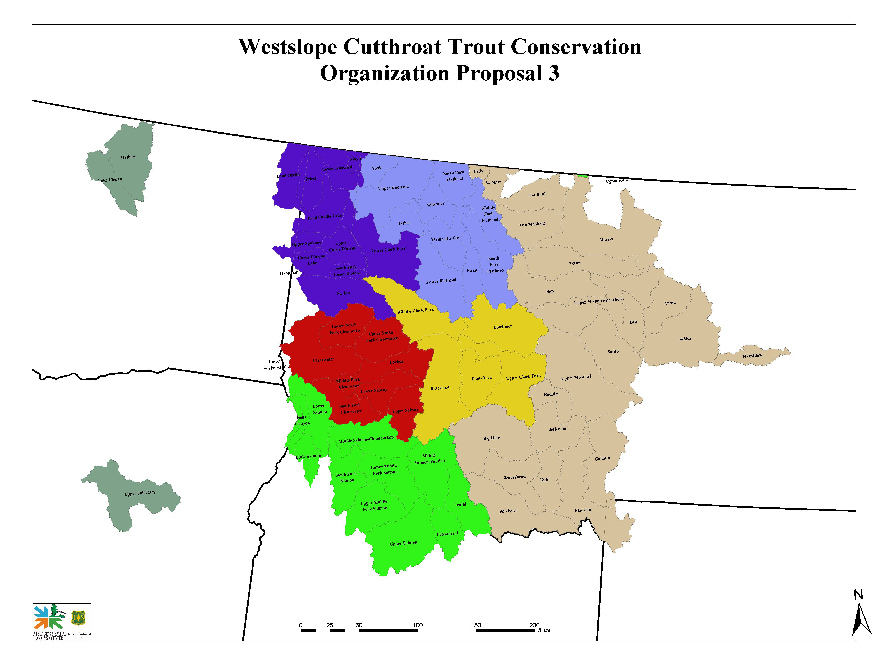

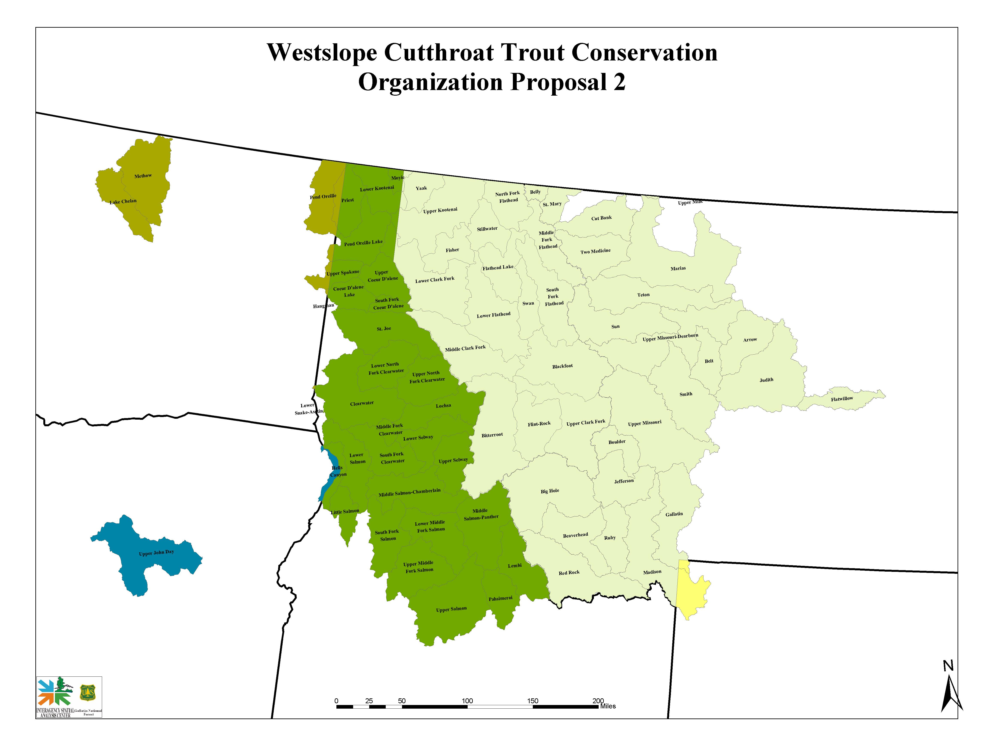
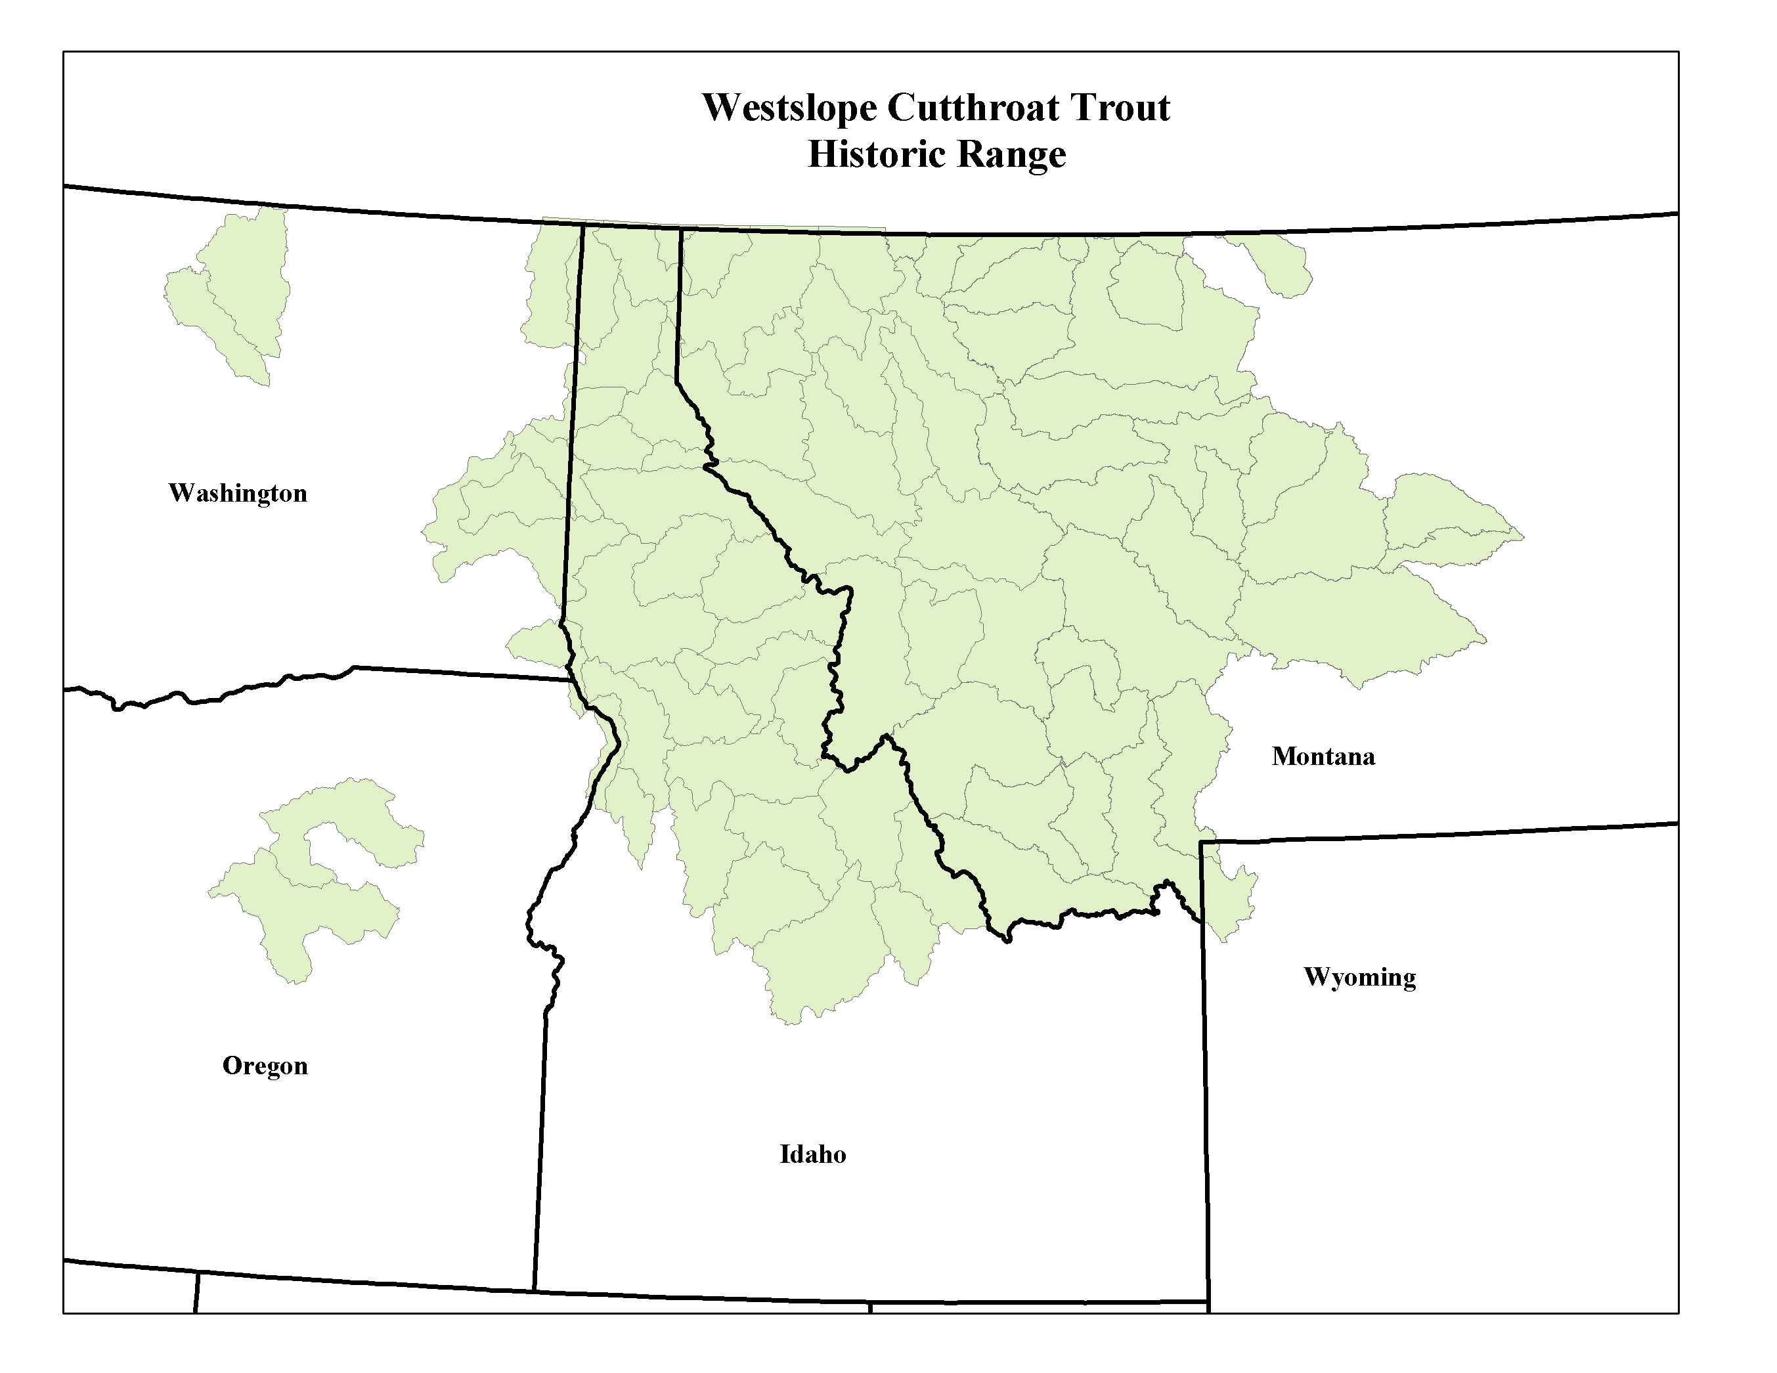

The percentage of the total population size that would be composed of reproductively mature fish would vary depending on whether population sampling included all fish age 0 and older or only those fish age 1 and older. Personal communication on the subject between Bruce Rieman, Kevin Meyer, Brad Shepard and myself resulted in a consensus opinion that 20% represents a reasonable estimate of the proportion of adults (if the total population sampling included sub-adults consisting of age 0 and/or age 1+ fish) within an average WCT population. If there is specific information regarding the proportion of reproductively mature adults within a population that information should be used to project the total population size.

